Noise pollution monitoring system

# Introduction:

Noise pollution is a pervasive environmental issue that can have detrimental effects on human health, wildlife, and overall quality of life. To address this concern, various noise pollution monitoring systems have been developed. These systems play a crucial role in assessing, managing, and mitigating noise pollution in urban, industrial, and residential areas. In this introduction, we will explore the fundamental aspects of a noise pollution monitoring system.

****What is Noise Pollution?****

Noise pollution refers to the presence of excessive, unwanted, or harmful sounds in the environment, often originating from human activities such as transportation, construction, industrial processes, and recreational activities. Prolonged exposure to high levels of noise pollution can lead to health problems, including hearing loss, sleep disturbances, stress, and cognitive impairment.

**Purpose of Noise Pollution Monitoring Systems:**

The primary objectives of noise pollution monitoring systems are:

* **Assessment:** To measure and record noise levels in various locations and at different times to assess the extent and severity of noise pollution.
* **Compliance:** To ensure that noise levels comply with local regulations and standards, which may include permissible noise limits during specific hours.
* **Identification:** To identify noise sources, patterns, and sources of excessive noise pollution.
* **Mitigation:** To provide data that can be used to implement noise reduction measures and policies.

Abstract:

Noise pollution is a growing concern in urban and industrialized areas, impacting the well-being of residents and ecosystems. This abstract introduces a Noise Pollution Monitoring System (NPMS) designed to assess, manage, and mitigate noise pollution. The NPMS comprises sensor networks, data acquisition systems, data loggers, and central monitoring stations, allowing real-time monitoring and analysis of noise levels. It serves as a critical tool for authorities, urban planners, and businesses to ensure compliance with noise regulations, identify noise sources, and implement noise reduction measures. By providing data-driven insights, the NPMS contributes to a quieter and healthier environment, enhancing the quality of life for communities affected by noise pollution

In an increasingly urbanized world, noise pollution has emerged as a significant environmental concern, impacting public health and well-being. To address this issue, Noise Pollution Monitoring Systems (NPMS) have been developed to systematically measure, record, and analyze noise levels in various settings. This abstract delves into the fundamental components and benefits of NPMS. These systems consist of sensor arrays, data acquisition units, data storage, and centralized monitoring stations. They serve as indispensable tools for assessing compliance with noise regulations, identifying sources of noise pollution, and proactively implementing noise control measures. NPMS not only empower decision-makers with real-time data but also promote public awareness and contribute to the creation of quieter and more sustainable urban environments. This abstract underscores the critical role of NPMS in managing and mitigating noise pollution, ultimately enhancing the quality of life for communities worldwide.

**Design:**

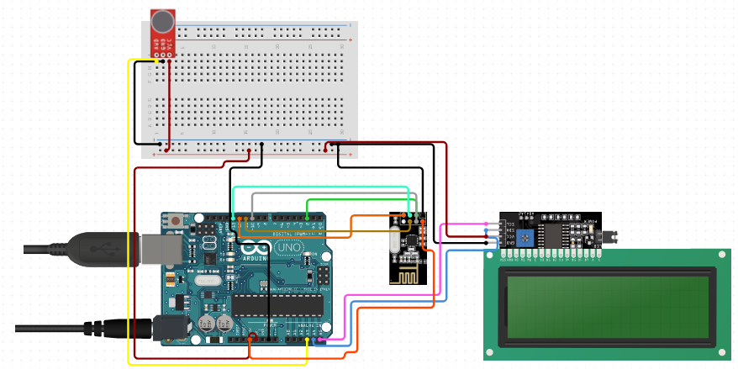

**Components:**

**A Noise Pollution Monitoring System (NPMS) based on the Internet of Things (IoT) leverages IoT technology to collect, transmit, and analyze noise data. Here are the key components typically found in an IoT-based NPMS:**

1. **Noise Sensors or Microphones:** These are IoT-enabled noise sensors or microphones that detect sound waves and convert them into digital data. These sensors are often equipped with built-in processors and communication capabilities.
2. **Data Acquisition and Processing Unit:** This unit processes the data from the noise sensors, which may include filtering, amplification, and digitization of sound signals. It can also perform initial data analysis on-site to reduce the data transmitted, saving bandwidth.
3. **IoT Connectivity Module:** An IoT connectivity module (e.g., Wi-Fi, LoRaWAN, NB-IoT) is integrated into the system to enable wireless communication between the monitoring points and the central server or cloud platform. The choice of connectivity depends on the range and coverage required.
4. **Central Server or Cloud Platform:** This component serves as the central hub for data collection, storage, and analysis. It receives data from multiple monitoring points in real-time and provides a platform for data visualization, analysis, and management.
5. **User Interface:** A user-friendly web-based or mobile application allows users to access and interact with the data collected by the NPMS. It provides real-time noise level displays, historical data analysis, and configurable alerts.
6. **Power Supply:** IoT-based monitoring systems may require efficient power management to ensure continuous operation. This can include low-power components, battery backup, or even energy harvesting solutions like solar panels.
7. **Security Features:** Robust security measures are essential to protect the data transmitted and stored by the NPMS. Encryption, authentication, and access control are critical components for securing IoT-based systems.
8. **Geolocation Services:** GPS or other geolocation services may be integrated to provide accurate location information for each monitoring point. This is valuable for mapping noise sources and monitoring changes in noise levels across different areas.
9. **Remote Management Tools:** Remote control and maintenance capabilities allow administrators to configure and update monitoring devices remotely, reducing the need for physical intervention.
10. **Data Storage and Analytics:** Noise data is stored securely, and analytics tools may be employed to identify patterns, trends, and anomalies in noise levels. This data can be used for reporting and decision-making.
11. **Alerting and Notification System:** An alerting mechanism can be set up to send notifications when noise levels exceed predefined thresholds or when unusual noise events are detected.
12. **Integration with Other IoT Systems:** Depending on the application, the NPMS may integrate with other IoT systems, such as weather sensors, traffic monitoring, or air quality monitoring, to provide a more comprehensive view of environmental conditions.

In summary, an IoT-based Noise Pollution Monitoring System combines sensors, data processing, communication, and cloud-based analysis to provide real-time noise data and insights for managing and mitigating noise pollution efficiently.

**Related Design:**

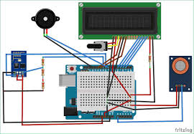

****Conclusion:****

**In conclusion, the development and implementation of Noise Pollution Monitoring Systems (NPMS) represent a crucial step in addressing the pervasive issue of noise pollution in our modern world. These systems, enabled by IoT technology, provide real-time data collection, analysis, and reporting, empowering communities and authorities to make informed decisions for noise pollution control and mitigation.**NPMS not only assist in assessing compliance with noise regulations but also serve as early warning systems, identifying noise sources and trends before they become severe. With the ability to monitor noise levels continuously and remotely, these systems offer an efficient means of reducing the adverse effects of noise pollution on human health and the environment.

***THANK YOU***